Fake Currency Detection Using MATLAB
Shishir Mathur, Vibhu Sharma, Nikhil Yadav
^{VIT University, Chennai Campus}

Abstract: The main objective of this project is fake currency detection using the image processing. Fake currency detection is a process of finding the forgery currency. After choose the image apply preprocessing. In pre-processing the image to be crop, smooth and adjust. Convert the image into gray color. After conversion apply the image segmentation. The features are extracting and reduce. Finally compare the image into original or forgery.
- Introduction
Digital image processing is the use of computer algorithms to perform image processing on digital images. As a subcategory or field of digital signal processing, digital image processing has many advantages over analog image processing. It allows a much wider range of algorithms to be applied to the input data and can avoid problems such as the build-up of noise and signal distortion during processing. Since images are defined over two dimensions (perhaps more) digital image processing may be modeled in the form of multidimensional systems. Digital image processing allows the use of much more complex algorithms, and hence, can offer both more sophisticated performance at simple tasks, and the implementation of methods which would be impossible by analog means. Image segmentation is the process of partitioning a digital image into multiple segments (sets of pixels, also known as superpixels). The goal of segmentation is to simplify and/or change the representation of an image into something that is more meaningful and easier to
analyze. Image segmentation is typically used to locate objects and boundaries (lines, curves, etc.) in images. More precisely, image segmentation is the process of assigning a label to every pixel in an image such that pixels with the same label share certain characteristics. Image restoration is different from image enhancement in that the latter is designed to emphasize features of the image that make the image more pleasing to the observer, but not necessarily to produce realistic data from a scientific point of view. Image enhancement techniques (like contrast stretching or de-blurring by a nearest neighbor procedure) provided by "Imaging packages" use no a priori model of the process that created the image. With image enhancement noise can effectively be removed by sacrificing some resolution, but this is not acceptable in many applications. In a Fluorescence Microscope resolution in the z-direction is bad as it is. More advanced image processing techniques must be applied to recover the object. Counterfeit money is imitation currency produced without the legal sanction of the state or government. Producing or using counterfeit money is a form of fraud or forgery. Counterfeiting is almost as old as money itself. Plated copies have been found of Lydian coins which are thought to be among the first western coins. Before the introduction of paper money, the most prevalent method of counterfeiting involved mixing base metals with pure gold or silver. A form of counterfeiting is the production of documents by legitimate printers in response to fraudulent instructions.

2. Overall Algorithm:
A. Image of paper currency will be acquired by simple scanner or digital camera.
B. The image acquired is RGB image and then it will be converted into gray scale.
C. Edge detection of the whole gray scale image will be performed.
D. After detecting edges, the four characteristics of the paper currency will be cropped and segmented. E. After segmentation, the characteristics of the paper currency will be extracted.
F. The characteristics of test image are compared with the original pre-stored image in the system.
G. If it matches then the currency is genuine otherwise counterfeit.

3.2 Modules:

3.2.1 Image Acquisition:
The first stage of any vision system is the image acquisition stage. After the image has been obtained, various methods of processing can be applied to the image to perform the many different vision tasks. Performing image acquisition in image processing is always the first step in the workflow sequence because, without an image, no processing is possible. There are various ways to acquire image such as with the help of camera or scanner. Acquired image should retain all the features.

3.2.2.Pre-processing:
The main goal of the pre-processing to enhance the visual appearance of images and improve the manipulation of datasets. Pre-processing of image are those operations that are normally required prior to the main data analysis and extraction of information. Image preprocessing, also called image restoration, involves the correction of distortion, degradation, and noise introduced during the imaging process. Image pre-processing can significantly increase the reliability of an optical inspection. Several filter operations which intensify or reduce certain image details enable an easier or faster evaluation. Image Adjusting is done with the help of image interpolation. Interpolation is the technique mostly used for tasks such as zooming, rotating, shrinking, and for geometric corrections. Removing the noise is an important step when image processing is being performed. However noise may affect segmentation and pattern matching. When performing smoothing process on a pixel, the neighbor of the pixel is used to do some transforming. After that a new value of the pixel is created.
3.2.3.Gray Scale Conversion:
The image acquired is in RGB color. It is converted into gray scale because it carries only the intensity information which is easy to process instead of processing three components R (Red), G(Green), B(Blue). to take the RGB values for each pixel and make as output a single value reflecting the brightness of that pixel. One such approach is to take the average of the contribution from each channel: (R+B+C)/3. However, since the perceived brightness is often dominated by the green component, a different, more "humanoriented", method is to take a weighted average, e.g.: 0.3R + 0.59G + 0.11B.
3.2.4. Edge Detection:
Edge detection is the name for a set of mathematical methods which aim at identifying points in a digital image at which the image brightness changes sharply or, more formally, has discontinuities. The points at which image brightness changes sharply are typically organized into a set of curved line segments termed edges. The same problem of finding discontinuities in 1D signals is known as step detection and the problem of finding signal discontinuities over time is known as change detection. Edge detection is a fundamental tool in image processing, machine vision and computer vision, particularly in the areas of feature detection and feature extraction. Edge detection is an image processing technique for finding the boundaries of objects within images. It works by detecting discontinuities in brightness. Edge detection is used for image segmentation and data extraction in areas such as image processing, computer vision, and machine vision.
Based on this one-dimensional analysis, the theory can be carried over to twodimensions as long as there is an accurate approximation to calculate the derivative of a two-dimensional image. The Sobel operator performs a 2-D spatial gradient measurement on an image. Typically it is used to find the approximate absolute gradient magnitude at each point in an input grayscale image. The Sobel edge detector uses a pair of 3x3 convolution masks, one estimating the gradient in the x-direction (columns) and the other estimating the gradient in the y-direction (rows). A convolution mask is usually much smaller than the actual image. As a result, the mask is slid over the image, manipulating a square of pixels at a time.
3.2.5. Image Segmentation:
Image segmentation is the process of partitioning a digital image into multiple segments (sets of pixels, also known as superpixels). The goal of segmentation is to simplify and/or change the representation of an image into something that is more meaningful and easier to
analyze. Image segmentation is typically used to locate objects and boundaries (lines, curves, etc.) in images.
3.2.6. Feature Extraction:
Feature extraction is a special form of dimensional reduction. When the input data to an algorithm is too large to be processed and it is suspected to be very redundant then the input data will be transformed into a reduced representation set of features. Transforming the input data into the set of features is called feature extraction. If the features extracted are carefully chosen it is expected that the features set will extract the relevant information from the input data in order to perform the desired task using this reduced representation instead of the full size input.
4. Results:
4.1 Edge-detected Image
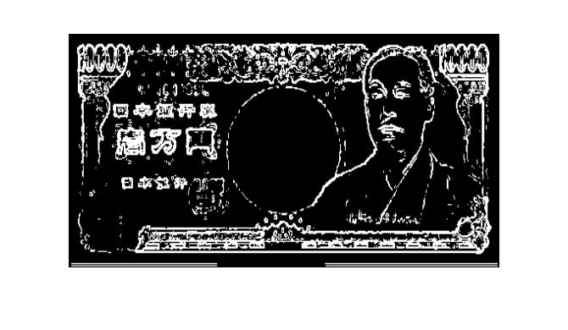
4.2 Test Sections of Standard and Query Image
4.2.1 TS-1

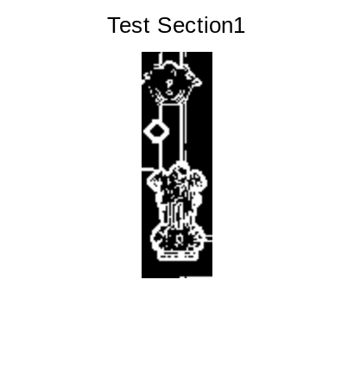
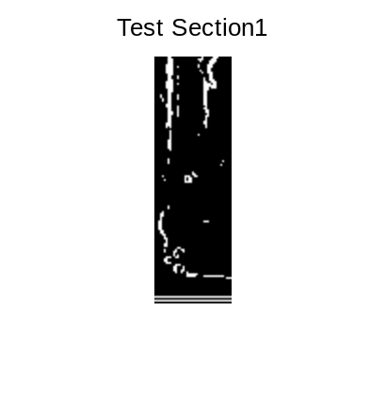
4.2.2 TS-2
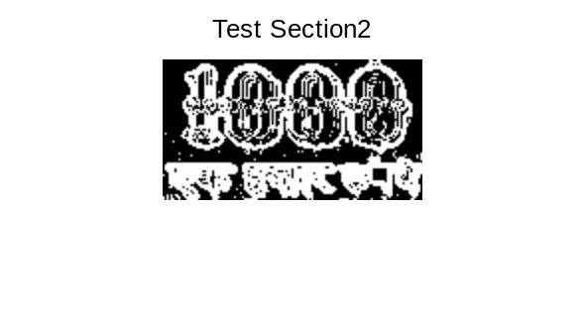

4.2.3 TS-3
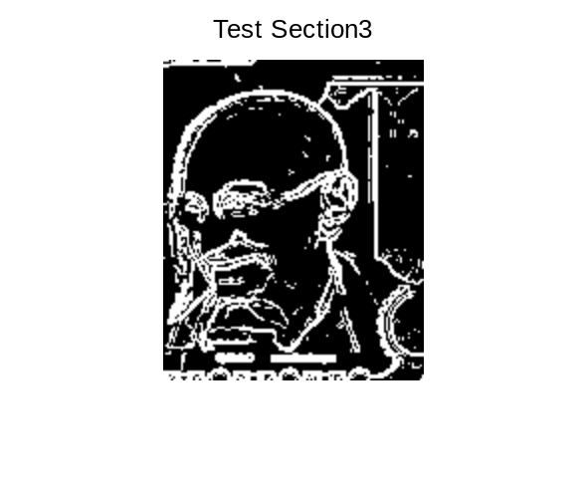
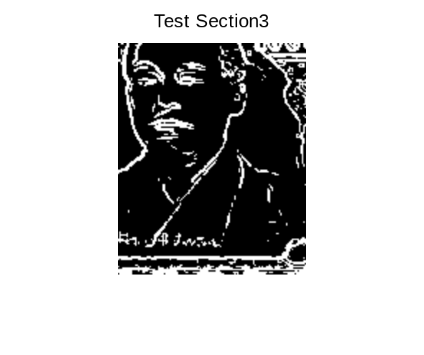
Experimental Results:
Performance Metrics:
- Earth-mover Distance
- Correlation

Output:
Percentage similarity according to correlation is 1.731534e+00
Earth mover Distance is 566525.

5. Conclusion:
This project proposed fake currency detection using image processing. In image pre-processing the image was cropped, adjusted and smoothed. Then the image converted into gray scale. After conversion the edges are detected. In edge detection used the sobel operator. Next the image segmentation is applied. After segmentation the features are extracted. Finally compared and find the currency original or fake.

6. Future Extraction:
In future this work will be extended on a basis of accuracy, by taking the level of difference the project tells into account and how much physical differences affect this model. This can only be done by testing and improving the project more and more.

7. Acknowledgement
We wishe to acknowledge our Content Based Image and Video Retrieval teacher Mrs. Geetha S for helping us with her vast knowledge throughout the development of this project.

8. References:
[1] Yufeng Kou, Chang-Tien Lu, Sirirat Sinvongwattana S. ans Yo-Ping Huang, Survey of Fraud Detection Techniques, IEEE International Conference on Networking, Sensing & Control, 0-78038193-9/04/$17.0020 2004 IEEE.
[2] D. Alekhya, G. DeviSuryaPrabha and G. Venkata Durga Rao, Fake Currency Detection Using Image Processing and Other Standard Methods, International Journal of Research in Computer and Communication Technology, Vol 3, Issue 1, January- 2014

[3] Indian Currency Identification Using Image Processing Shyju S1, Prof. Thamizharasi A2

[4] Currency Recognition System Using Image Processing S. M. Saifullah, AnikaRahmanAnanna, Md. Shakhawat Hossain, Md. Jaouad Hossain,Md. SaniatRahman Zishan

[5] Indian Currency Recognition and Verification Using Image Processing
Ingulkar Ashwini Suresh, Prof.P.P.Narwade

[6] Currency recognition system using image processing Yaojia Wang Siyuan Lin June 2010

